**Sir Syed University of Engineering & Technology**

ANSWER SCRIPT

|  |  |
| --- | --- |
| Date: | June 17,2021 |
| Roll Number: | CS19-037 |
| Section: | A |
| Name: | Munib ul Hassan |
| Course Name: | CS-328: Data Communication and Networks |
| Degree Program: | BSCS |
| Total number of pages being submitted: | 7 |





My Roll No: 037

X = 037

Y = 0 + 3 + 7 = 10

Z = last two digit of roll no = 37

A = 3 + 7 = 10

**ANSWER # 01(a):**

1. We are sending (37 * 1000) 37000 bits from host A to host B with a speed of (last digit is 7) 7Mbps by circuit switching

Each circuit has a transmission rate of (7Mbps)/37 = 189.189kbps

It takes 37000 bits/189.189 kbps = 0.1955 seconds to transmit the file.

iii. Y * 100 = 10 * 100 = 1000msec

1000 * 3 (for 3 request) 3000 msec = 3 sec

Total time = 0.1955 + 3 = **3.1955 sec**

**ANSWER # 01(b):**

**Data:**

Bandwidth = y * 1000 Hz = 10000 Hz

Signal to noic ratio = 37 Db

Capacity = ?

**Formula:**

Capacity = bandwidth in Hz * log2(1+SNR)

**Solution:**

Capacity = 10000 * log2(1+37)

Capacity = 10000 * log2(38)

Capacity = 10000 * 5.247

**Capacity = 5247**

if we double the value of signal to noise ratio, the channel capacity Is also increases.

**ANSWER # 02:**

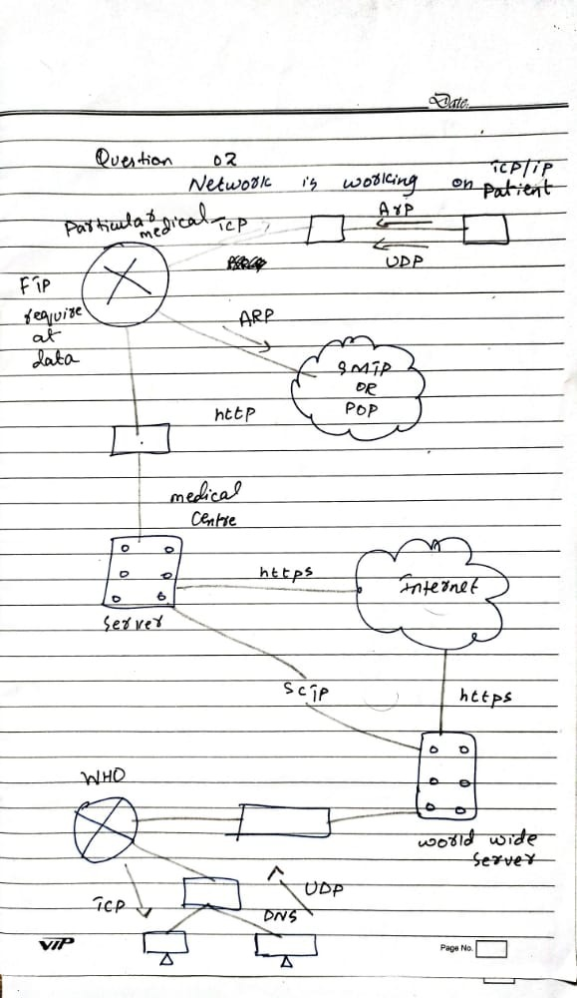

**ANSWER # 03:**

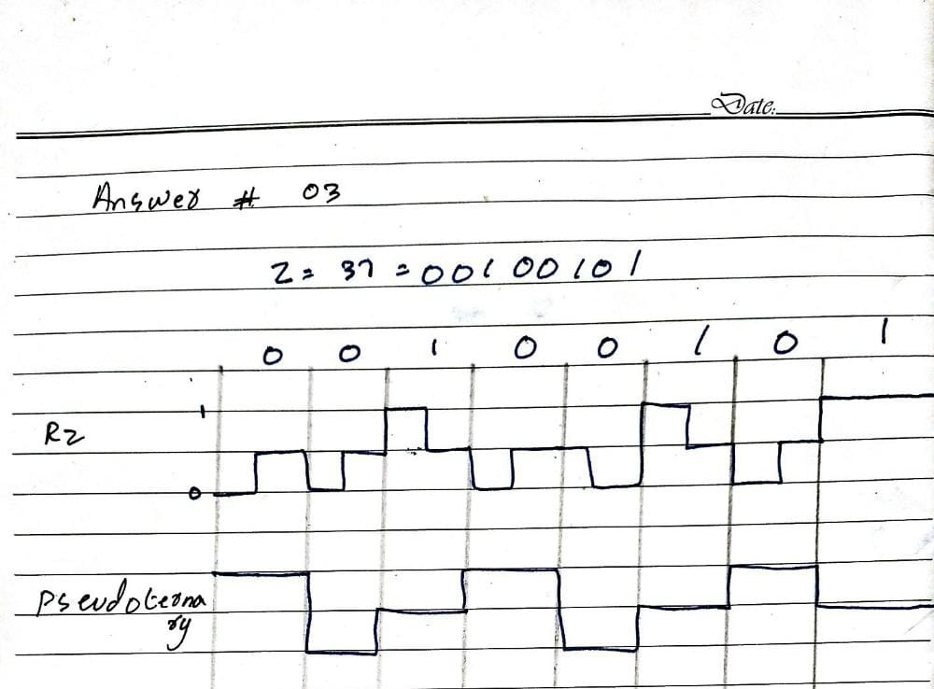

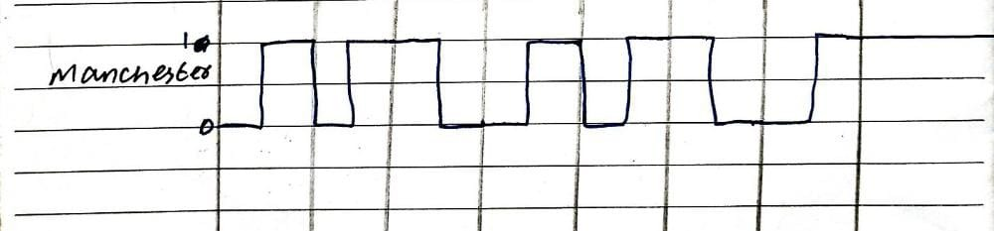

It is necesorry to convert analof data into digtal signal because any digital process needs digital input for procesin. Transporting and storing data.

**ANSWER # 04:**

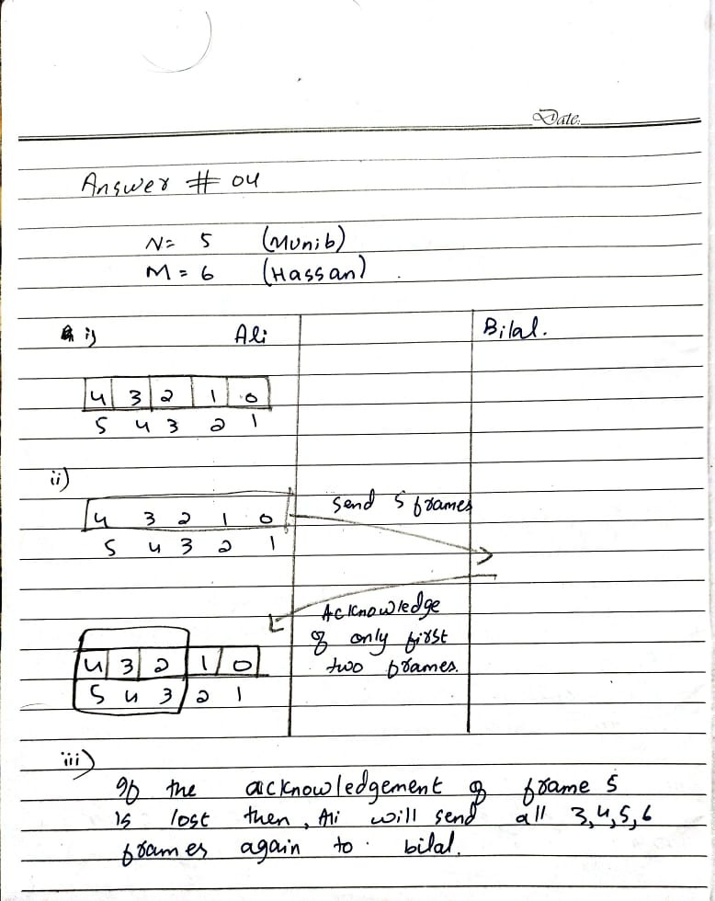

**Data:**

Bit rate = 10 * 1000 = 10000bps

Length of the link = 37 * 100 = 3700 meters

Velocity = 37 m/s

Bit length = ?

**Formula:** Bith length = (2 * ) * bandwidth

**Solution:**

Bith length = (2 * ) * 10000

Bith length = (2 * 100) * 10000 = **2000000 bits**

**ANSWER # 05:**

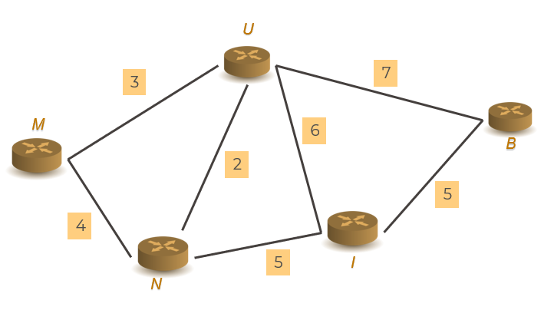

1. The shortest path of the abouve diagram is 2 from **U** to **N** and 3 from **M** to **U**
2. Entries table for node M and U

|  |  |  |
| --- | --- | --- |
| **TABLE FOR M** | | |
| **DISTANCE** | **DISTANCE** | **NEXT** |
| **M** | **0** | **M** |
| **U** | **3** | **U** |
| **N** | **4** | **N** |
| **I** | **∞** | **-** |
| **B** | **∞** | **-** |

|  |  |  |
| --- | --- | --- |
| **TABLE FOR U** | | |
| **DISTANCE** | **DISTANCE** | **NEXT** |
| **M** | **3** | **M** |
| **U** | **0** | **U** |
| **N** | **2** | **N** |
| **I** | **6** | **I** |
| **B** | **7** | **B** |

1. If we double the cost of the link our network takes time for transferring the packet into desired location and efficiency of the network is effect.
2. In my design network, there is 5 nodes and having cost of each lnk in my network there is no direct way to transfer packet from M to I, B and from N to B from I to M and from B to M, N.

COMPLETE PROCESS

Suppose ,we are proceed to send packet from M to B

1. At M there is 2 paths to N and U having cost 3 and 4. As algorithm move to the having low cost in compareof others so first packet move at node U.
2. At U there is multiple paths but our destination is B having cost 7 the packet move to B and having total cost = 3 + 7 = 10

